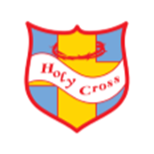
Holy Cross Catholic Primary School

‘Loving and learning together in faith.’

Behaviour Principles Written Statement

Statement of Intent

This policy promotes our core belief in children’s right to learn, in a safe and nurturing environment. At Holy Cross Catholic Primary School, we are committed to creating an environment where positive behaviour is at the heart of productive learning. Everyone is expected to maintain the highest standards of personal conduct, to accept responsibility for their behaviour & encourage others to do the same.
As members of our community, we adhere to these four core rights: ‘Be happy, Be Safe and Be treated with respect and to learn.’ These are shared and discussed age appropriately within classes.

