|  |  |  |  |  |  |
| --- | --- | --- | --- | --- | --- |
| **Autumn 1** | **Autumn 2** | **Spring 1** | **Spring 2** | **Summer 1** | **Summer 2** |
| All About Me | Space | New Year | World Book Day | Food | Growing and Seasons |
| Where we Live | Bonfire Night  Remembrance Sunday | Winter | Easter | Father’s Day | Summer |
| Traditional Tales | Children in Need | Chinese New Year | Mother’s Day | Animals | Holidays |
| People Who Help Us | Christmas | Shrove Tuesday | Spring | Seaside |
| Autumn | Valentine’s Day | Mini-beasts | Nursery Rhymes | Starting School (F1) |

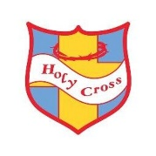

**Holy Cross Catholic Primary School**

**EYFS Curriculum Map**