Holy Cross Catholic Primary School
Family Newsletter

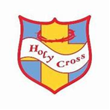

October 2021

Dear families,

It’s hard to believe we have finish today for the half term break. Time is flying past so fast! The children have settled in so well and have worked so hard this first half term.

I hardly dare think about Christmas yet but we are already starting to think ahead to all our Christmas events and are making exciting plans. We let you know important dates when we return after the half term break.

Thank you for your continued help and support, it really does make all of the difference. I wish you all an enjoyable and restful half term break and I’m already looking forward to welcoming children back on Tuesday 2nd November.

Please remember that Monday 1st November is an INSET day and school will be closed for pupils.

Thank you for all your support.

Mrs Higgins

Parents Evening
Due to current COVID-19 restrictions we are still unable to invite you all into school for consultations with your child’s teacher. ‘Parent Consultation Phone Calls’ will take place the week beginning the 8th November and 15th November.
This isn’t the way we would normally update you on your child’s progress, but we were keen that parents have the opportunity to have speak with their child’s teacher. It will allow the staff to update you on your child’s progress and how they have settled back into school life and their class but will also give you as parents a chance to share any concerns or worries and ask any questions.
The dates for each year group will be sent out after the half term break. Please remember if you have any questions or concerns, please always contact your child’s class teacher or myself.

Year Six High School Applications – starting high school in September 2022
If your child is in Year 6 and due to start secondary school in September 2022, you must apply for your preferred secondary school place by 31st October 2021.

Foundation Stage Two (Reception) Applications – starting high school in September 2022
If your child is due to start Foundation Stage Two (Reception) in September 2022, the application window is also open. You must apply by 15th January 2022. If anyone would like support with these applications, please let us know as soon as possible.
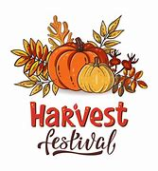
Harvest Donations
Thank you so much for all your wonderful donations for our Harvest Festival, we really did appreciate all your support and help.

We have spaces in our main Nursery for any child who is 3 or 4. If your child requires a space in Nursery please make sure you have completed an application form and we have their name down. We offer 15 hours funded places, alongside 30 hours funded places for parents who are eligible. We also offer ‘pay as you go’ places, were parents and carers are able to pay for additional nursery sessions as they need them.
Please contact Mrs Brás through the school office for more information.

Attendance – Classopoly

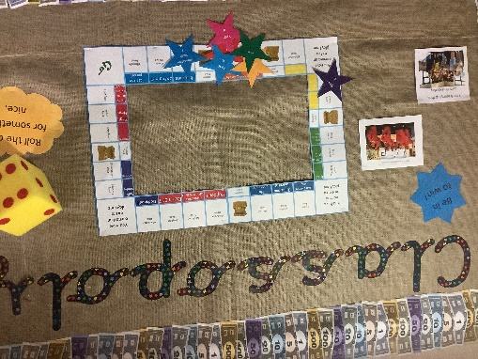

We are thrilled to announce that every class across the school has achieved 96% attendance at least once this half term. This means that they have been able to roll the dice on our Classopoly Board and have won prizes such as a Teddy bear’s picnic, being artists for the afternoon, bubble fun and an own clothes day.

Huge thanks to all families for supporting us in making this amazing start to our attendance this half term.
Learning around our school

We wanted to share with you some of the fabulous learning that has taken place this half term.

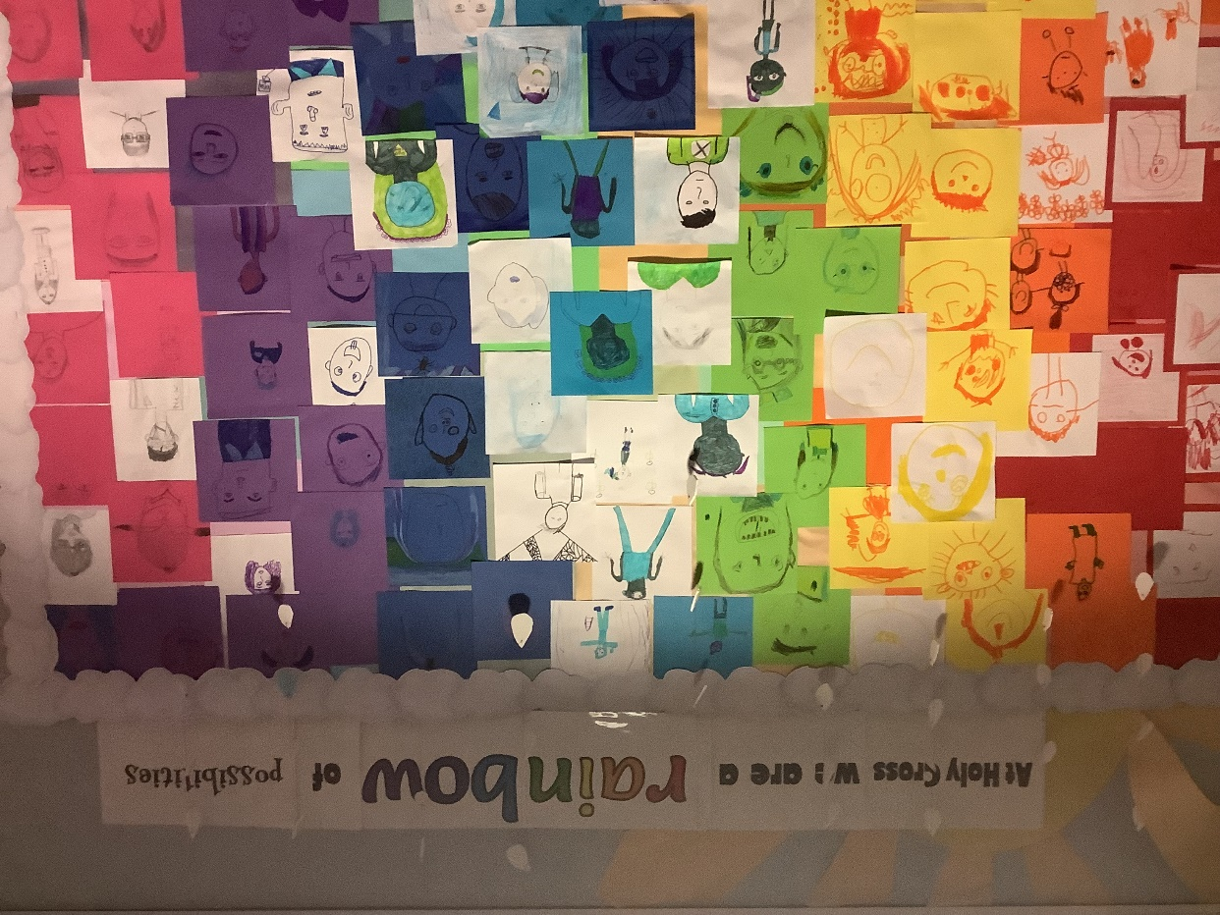

Whole school PSHE project – exploring possibilities and ambitions

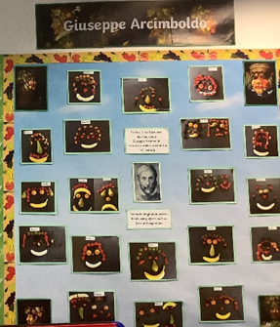

Learning about the parts of a plant by Year One and Year Two have been exploring the artist Guiseppe Arcimboldo

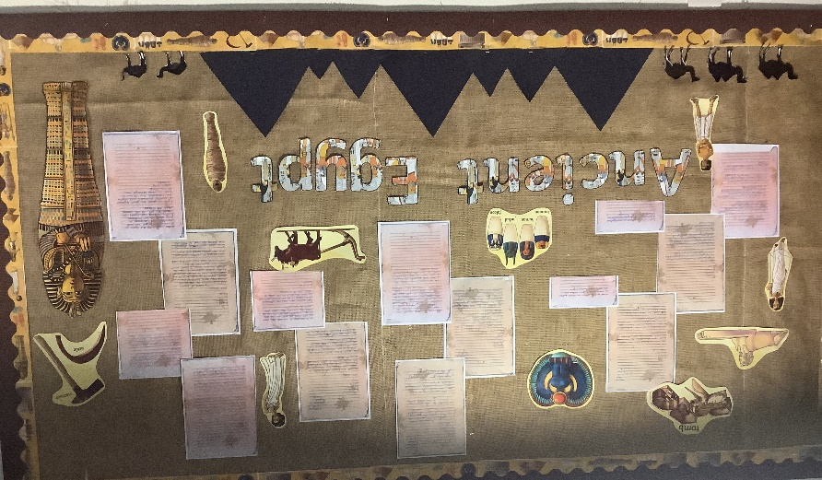

Year Three have been learning about Ancient Egypt

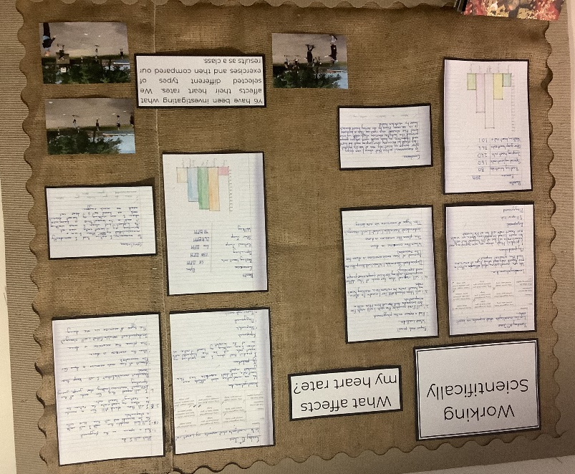

Year Six as Scientists, exploring what affects their heart rate

