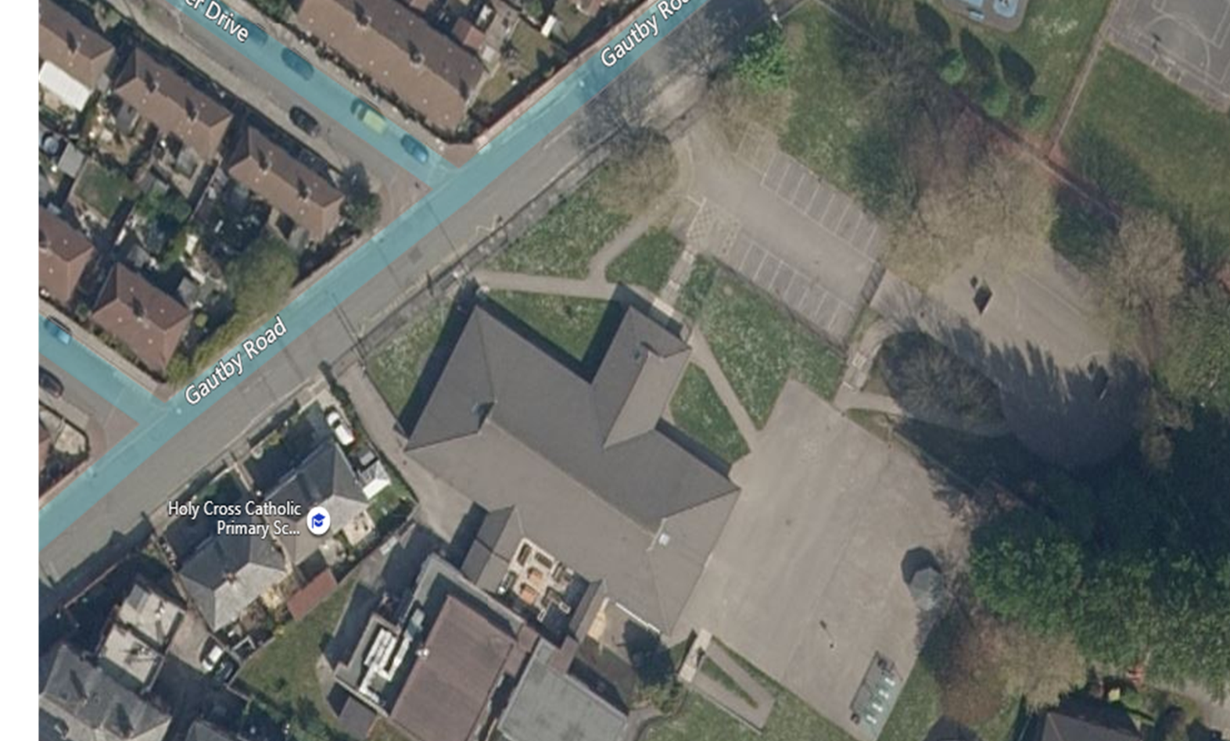

F1 parents and children line up (yellow route - morning only)

F2 & Ks1 children line up

F2 andKS1 drop off and collection

KS2 Drop off and collection point.

KS2 children say goodbye to parents at the playground gate and then walk to their year group sign. Parents then follow the one-way system (blue route) back onto Gautby Road.