 | RA 029 Addendum –Enhanced Support Area v1 June 2021 | MODEL RISK ASSESSMENT  RECORDING FORM

Location or School/college/setting  Address: | Date assessment  Undertaken 21/06/21 | Assessment undertaken  by : Jeanne Fairbrother and C. Higgins (HT)
Activity or situation:  Addendum Enhanced Support Area | Review  date: Weekly review | Signature: C. M. Higgins

Enhanced Support Area
Locally rates of Covid-19 have increased of recent weeks and to prevalence of the Delta variant has led to an acceleration of cases in settings. In response to this situation a range of additional measures to help reduce the spread of the virus have been put in place by the DfE and local PHE teams. The measures below are in addition to other interventions that currently take place in School/college/settings and the local community.

The general principle is that early years, schools and colleges must continue to risk assess and plan activities in line with the system of controls and should follow government guidance. School/college/settings are asked to reinforce and strengthen existing measures form their risk assessments.
Local authorities, Directors of Public Health (DsPH) and PHE Health Protection Teams (HPTs) are responsible for managing localised outbreaks. They play an important role in providing support and advice to education and childcare settings .They have set out their positions on common activities below in their letter 18th June 2021.
See also Coronavirus (COVID 19) local restrictions in education & childcare https://www.gov.uk/government/publications/coronavirus-covid-19-local-restrictions-in-education-and-childcare-settings?utm_medium=email&utm_campaign=govuk-notifications&utm_source=9b4f7842-f396-4148-9d11-25f7e9e74332&utm_content=immediately 18th June 2021
School/college/setting already have their RA 029 full opening risk assessment based on the system of controls outlined in the DfE’s School/college/setting s coronavirus (COVID-19) operational guidance & Actions for School/college/setting s during the coronavirus outbreak . It covers the following School/college/setting s:
- early years settings
- primary School/college/setting s
- secondary School/college/setting s (including sixth forms)
- special School/college/setting s, special post-16 providers and alternative provision
- independent School/college/setting s
- wraparound & extracurricular providers

Please note that this risk assessment has been created in line with the current government guidance. School/college/settings need to ensure that this template reflects any local guidance and the specific needs of their School/college/setting .
Guidance
This risk assessment has regard to all relevant guidance and legislation including, but not limited to, the following:
- The Health Protection (Notification) Regulations 2010
- The Reporting of Injuries, Diseases and Dangerous Occurrences Regulations (RIDDOR) 2013
- Public Health England (PHE) (2017) ‘Health protection in School/college/setting s and other childcare facilities’
- NEW DfE (2021) ‘Schools coronavirus (COVID-19) operational guidance
- UPDATED DfE (2021) ‘Actions for early years and childcare settings during the coronavirus (COVID-19) outbreak’
- DfE (2021) ‘Face coverings in education’
Legislation and guidance
Health and Safety At Work Act etc. 1974
Management of H&S at Work Regulations 1999
Workplace (Health, Safety and Welfare) Regulations 1992
DfE Actions for School/college/setting s plus associated COVID 19 Guidance
Public Health England Guidance

1) Hazard / Activity | 2) Who can be harmed and how? | 3) What controls exist to reduce the risk?  Have you followed the hierarchy of controls (eliminate, substitute etc) | Risk Score  Consequence  X Likelihood | 4) Any further action;  This should be included in the action plan on overleaf
Failure to follow updated PHE/DfE guidance for Enhanced Support Areas | Staff, pupils, parents, visitors – failure of measures in place to reduce spread of Coronavirus (COVID 19) | - School/college/setting keeps up to date & follows latest local PHE guidance of additional measures required in Enhanced Support Area (ESA)  - For complex decisions and advice contact Local PHE Team or DfE Helpline on 0800 046 8687 option 1  - Cheshire & Merseyside PHE contact 0344 225 0562  - Greater Manchester Health Protection Unit 0844 225 1295  - Wirral School/college/settings contact by School support Hub Alison Simpson or Jane Harvey) who will get in touch with you as soon as possible.)  - Wirral Special Schools must contact Alison Simpson or Jane Harvey (above) | 2x2=4
Failure to follow additional general measures in PHE/DfE guidance | Staff, pupils, parents, visitors – failure of measures in place to reduce spread of Coronavirus (COVID 19) | - School/college/setting has reinforced the system of controls in COVID 19 Full opening risk assessment with staff and pupils.  - Reinforce -hygiene, regular sanitising when moving around the setting, increased ventilation & social distancing.  (RA 029 Full opening RA latest version 9.3 17th May 2021)  - Reinforce and strengthen ‘Hands, face, space, fresh air’ message with staff, pupils & visitors.  - Reinforce ‘bubble’ management – PHE guidance is staff should not be moving between bubbles  - Reinforce the need for stringent social distancing with staff :  - Unnecessary personal communication between staff  - Care exercised in staff rooms  - Care exercised when communicating in corridors etc.  - Adults to wear masks where 2m social distancing is not possible – communal areas, corridors.  - Reinforce particular care at pick up and drop off by parents and reintroduce face coverings and social distancing  - Reinforce enhanced cleaning of equipment between use by different groups.  - Prioritise use of outdoors or ensure areas are ventilated.  - Minimise non-essential travel, trips & mixing.  - PCR testing if symptomatic.  - Follow NHS Test & Trace instructions to self-isolate.  - Encourage all those eligible to have both doses of the vaccine. | 2x2=4
Testing | Staff, pupils, parents, visitors – failure of measures in place to reduce spread of Coronavirus (COVID 19) | - Ensure all staff take part in twice weekly LFD testing and record results. | 2x2=4
Face coverings other settings | Staff, pupils, parents, visitors - contracting Coronavirus (COVID 19) | - [All settings] Face coverings should be worn by staff and visitors in situations outside of classrooms where social distancing is not possible.  - School/college/setting does not require face coverings to be worn by those exempt from doing so, e.g. pupils with SEND who may struggle to wear one correctly or have their education impaired by wearing one.  - Anyone communicating to someone who relies on lip reading will also be exempt from wearing a face covering.  - Transparent face coverings, which may assist communication with someone who relies on lip reading, clear sound or facial expressions to communication, are worn where appropriate.  - Face visors or shields can be worn by those exempt from wearing a face covering but they are not an equivalent alternative in terms of source control of virus transmission. They should only be used after carrying out a risk assessment for the specific situation and should always be cleaned appropriately | 2x2=4
Shielding | Staff, pupils, parents, visitors increased risk of transmission of Coronavirus | - Shielding is currently paused.  - School/college/setting outbreak management plans are in place cover the possibility that shielding may be introduced by Government in areas of high transmission | 2x2=4
Outbreak management plans –  - residential educational visits  - open days  - transition or taster days  - parental attendance in settings  - performances in settings | Staff, pupils, parents, visitors increased risk of transmission of Coronavirus | - School/college/setting outbreak management plans cover the possibility we are advised to limit the following events if recommended to by the Local authority, Director of Public Health (DPH) and PHE Health Protection Teams (HPT)  - residential educational visits  - open days  - transition or taster days  - parental attendance in settings  - performances in settings  - School/college/setting will always refer to the latest - latest North West Supporting Guidance for School End of Term Activities – v1 shared by PHE 18/06/21 and subsequent versions as issued | 2x2=4
School/college/setting : trips/visits | Staff, pupils, parents, visitors increased risk of transmission of Coronavirus | - Refer to latest North West Supporting Guidance for School End of Term Activities – v1 shared by PHE 18/06/2121 and subsequent versions as issued  - DFE – school/college/setting will consider carefully if the educational visit is still appropriate and safe.  - Only children who are attending the setting will go on an educational visit. Education settings should consult the health and safety guidance on educational visits when considering visits. | 2x2=4

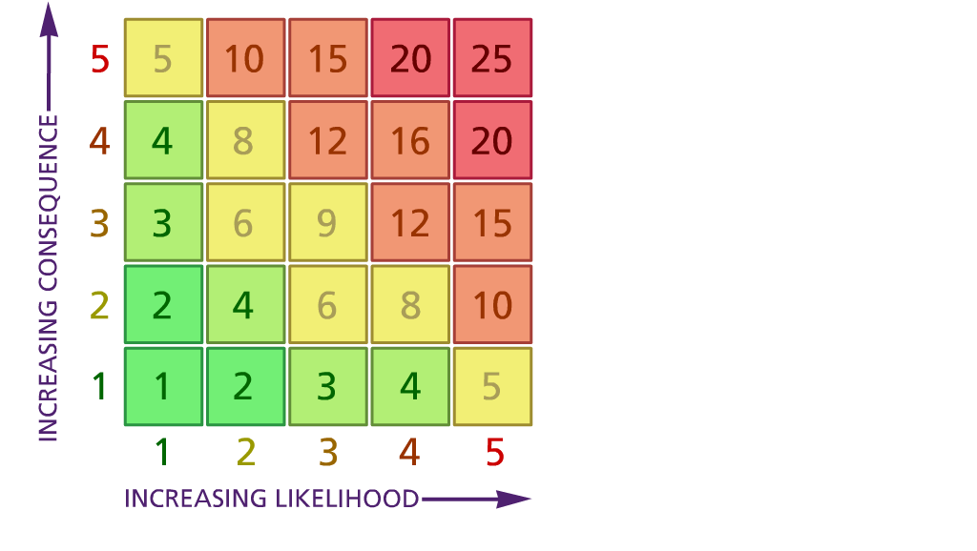
Risk Rating | Action Required
17 - 25 | Unacceptable – stop activity and make immediate improvements
10 - 16 | Tolerable – but look to improve within specified timescale
5 - 9 | Action – Improve within specific timescales
3 - 4 | Monitor – but look to improve at review or if there is a significant change
1 - 2 | Acceptable – no further action but ensure controls are maintained & reviewed

Likelihood: Consequence:

5 – Very likely 5 – Catastrophic

4 – Likely 4 – Major
3 – Fairly likely 3 – Moderate

2 – Unlikely 2 – Minor

1 – Very unlikely 1 – Insignificant
(1) List hazards something with the potential to cause harm here
(2) List groups of people who are especially at risk from the significant hazards which you have identified
- List existing controls here or note where the information may be found. Then try to quantify the level of risk the likelihood of harm arising that remains when the existing controls are in place based on the number of persons affected, how often they are exposed to the hazard and the severity of any consequence. Use this column to list the controls that you might take and develop all or some of that list into a workable action plan. Have regard for the level of risk, the cost of any action and the benefit you expect to gain. Agree the action plan with your team leader and make a note of it overleaf. If it is agreed that no further action is to be taken this too should be noted.

(5) ACTION PLAN

 | Action required | Responsible person | Completion date
1 | HT to ensure all staff , pupils and visitors comply with risk assessment RA029 | HT | ASAP
2 | HT to ensure all staff , pupils and visitors comply with mask wearing where appropriate | HT | ASAP
3 | HT to ensure all staff are aware of responsibilities around self-testing and procedures and sufficient stock | HT | ASAP
4 | HT to check with local authority for guidance and/or instruction | HT | ASAP
5
6
7
8
9
10
 | Name and date of person authorising actions: C. M. Higgins

