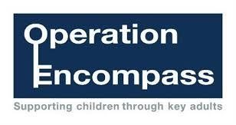
1st September 2021
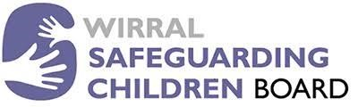
Dear Parents/Carers,

I am writing to let you know about the school’s continued involvement in Operation Encompass.

Operation Encompass is a safeguarding project that project that all schools in Wirral have participated in for the last three years.

The project, is being run in partnership with Merseyside Police. The project, which commenced on 6 October 2014, aims to support children who are affected by domestic abuse.

Merseyside police will contact schools at the start of the day and inform them of any domestic abuse incidents where the police attended the family home and the child/ children were present.

Each school has a member of staff (key adult) who is trained to liaise with the police, when required, whilst ensuring appropriate support is available to the child.

We welcome this project. We are committed to providing the best possible care and support for our pupils. Our school has a very pro-active approach to safeguarding. This is supported by excellent working practices with other safeguarding agencies.

If you would like to speak to someone further about the project or require further information, please do not hesitate to contact either Mrs Bras, Mr Hall or myself through the school office.

Yours sincerely

Mrs Clare Higgins
Head Teacher

